TheWaiting-Room.net
User Guide

Contents

Contents 3
Introduction 4
Registration 5
Activation 6
Amending your Details 7
Login and Logout 8
Login Page 8
Logout Page 9
Site Navigation 9
Requesting a New Password (Lost Username or Password) 10
Services 12
Appointment Requests 12
Medications 15
My Medication History 18
Allergies and Adverse Reactions 19

Introduction

Welcome to the Waiting Room

In order to utilise the services provided by the waiting-room.net you are required to supply a valid email address to your practice. This email address will then be used to give you updates and confirm requests made when using the site. This email address will also be used to receive the activation link for your profile.

There are a number of services that are available to both the patients and practice. These can be activated or de-activated based on what the practice deems appropriate.

Currently the main services available are:-
- Appointments
- Medication Requests
- Allergies and Adverse Reactions

Appointments
This service allows patients who are registered with The Waiting Room website to book Surgery appointments. The Surgery make some (not all) appointments available to these patients. The appointments offered are ‘advance’ appointments and any un-booked slots are available for the Surgery staff to use on the day of the appointment. The appointments are offered on a first come, first served basis and this is controlled by the website. The appointment booked on the website is confirmed by e-mail once the Surgery and website have synchronised – usually within two hours of the original request.

Medication Requests
The service allows patients who are registered with The Waiting Room website to order previously prescribed Medications. The website displays a list of the entire patient’s prescribed medications and clicking the button on an item will generate the request. In the same way as a request made on paper, the Surgery may either grant the request or refuse it if, for example, the doctor needs to review the medication before issuing the prescription. The system interacts directly with the Surgery system. The outcome of the request is e-mailed to the patient. There is also the facility to order previously prescribed Acute medication if this has been enabled by your practice. A comment can also accompany the request to indicate any special circumstance or collection arrangement.

Allergies and Adverse Reactions
This service allows the patient to view any recorded allergies or adverse reactions that are recorded on the practice record for that patient.

Your practice will be able to tell you what services you will be able to access within the site.

The latter part of this guide is divided into service areas for your convenience. However, parts 1 through 7 are common to all areas and should be read by all.

Registration

You may already have registered with your practice. If so, you may skip this section.

Registration for The Waiting Room Services is extremely simple. All your practice requires from you is a valid email address that is only useable by yourself together with a suitable form of identification. Check with your practice as to what is acceptable to them.

We advise that family owned or shared email accounts are not used for the purposes of the Waiting Room. However, in certain circumstances, this may be necessary. For example, you may have a nominated carer.

The practice you are registered with will add the email address to your confidential record so you need not worry about it being used for any other purpose outside of the practice policy.

Discuss with the practice which service or services they are making available to you for use with The Waiting Room.

The practice will then do the rest and you will receive an email when the registration has been completed. Should you not receive an email within two working days, check your “Junk Mail” folder. If the email is not there, contact your practice.

Activation

Once registered for The Waiting Room you will receive an email similar to that below:-

Some email clients may require you to press and hold the Ctrl key when clicking the link, please refer to the help file for your email client in the first instance if clicking the link does not work.

If the link does not work for any reason, you can copy and paste the full link from the text at the bottom of the message starting with https://www.thewaiting-room.net.... Into your browser address bar, taking care to copy all of the text.

Once the link has been selected (or manually entered into the address bar) you will proceed to TheWaiting-Room.net whereby you will be presented with a screen indicating that your account has been successfully activated, as shown below.
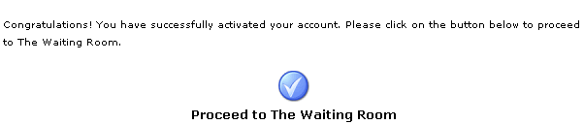

Selecting the blue tick will then take you to the “Edit Details” page, where you may update your account details. By default the information associated with your account will contain randomly generated information.

Your Username and Password should be amended to something more memorable to yourself at this point.

Amending your Details

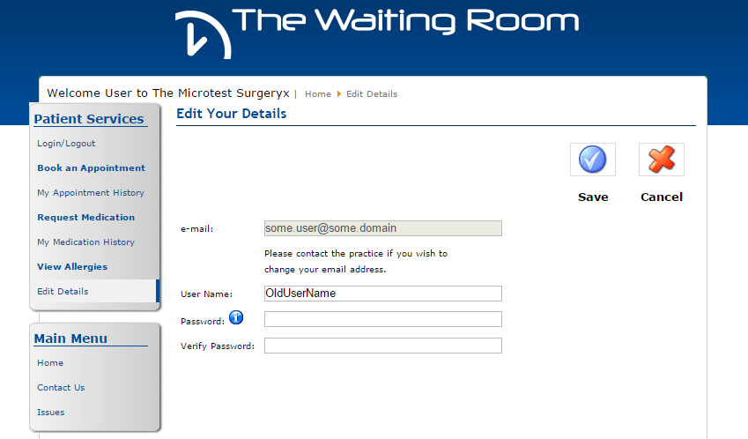

Within the ‘Edit Details’ section of the website you are given the ability to modify the majority of your current account information.

Below is a summary of the fields on the form and an overview of their use.

e-mail | For security, you cannot amend this. If it requires changing, please contact your practice.
User Name | This is what you will use to log onto the site so it should be memorable to you. If you should choose a username that has already been taken, don’t worry, the system will inform you and allow you to choose another. For added security, it is recommended that you do not use your real name.
Password | We advise that you use something that you will remember. However, you should not use words that could be guessed. Try using capital letters and numbers. For example, using “Rem0te5”, we have used a capital “R”, replaced the “o” with a “0” (zero) and finished with the number “5”. This type of password is called a strong password and cannot easily be guessed.
Verify Password | Re type the password you have chosen to make sure that it has not been mistyped. This is done to prevent you from, effectively, locking yourself out of your account.

Your Username and Password should not be given to anyone and neither Microtest nor your practice will ask you for this information.

Login and Logout
To both Login and Logout of the site select Login/Logout under Patient Services.

Login Page

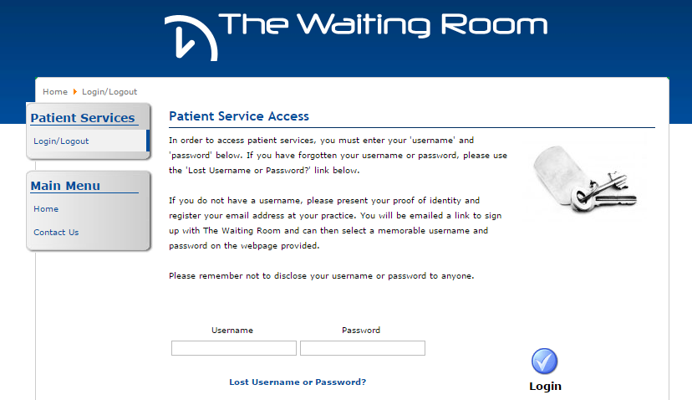

Simply type your Username and Password in the boxes provided and press enter on your keyboard or click on the Login button.

If you type the details incorrectly you will receive an Error Message.

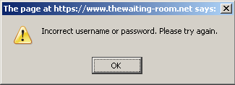

Simply click “OK” to try again. If you cannot remember your password then go to the Requesting a New Password (Lost Username or Password) section to reset it.

Once you have entered a valid Username and Password there will be a welcome message in the top right of the screen and a list of available services under the Patient Services menu.

Logout Page

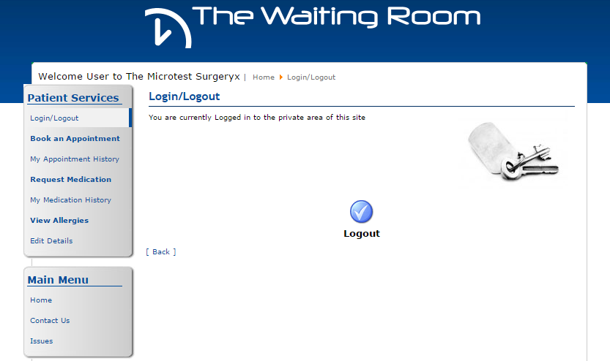

To logout simply click on the Login/Logout item under Patient Services and confirm by clicking the logout button.

For security reasons we recommend that you always log out of the site before closing the browser

Site Navigation

The site has a navigation menu that is available throughout once you are logged in. Each of the Patient Services options are described in more detail in the following sections.
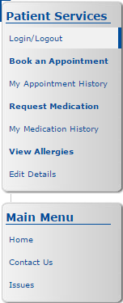

Requesting a New Password (Lost Username or Password)

If you cannot remember your Username or Password, select Login/Logout from the Waiting Room website and follow the Lost Username or Password link on the page.

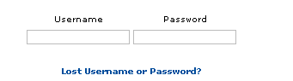

The link takes you to the password request page which requires your registered email address. Enter your email address and click on Send Username & Password.

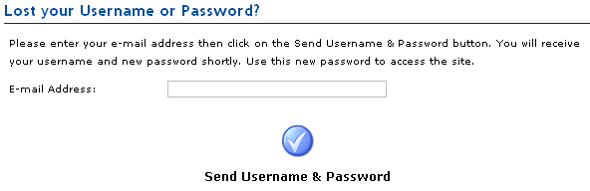

If, for any reason, the email address is not recognised, you will see a note above the Text “Lost your Password?” as per the image below.

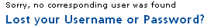

Re-enter your correct email address and click on Send Username & Password. If you cannot remember your email address, please contact your practice.

Upon successfully entering the details the page shows the following message:-
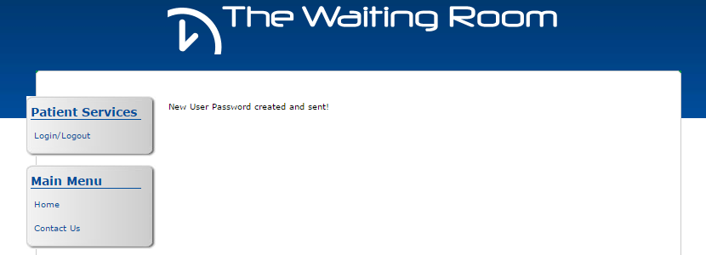

Services

Appointment Requests

When using the site to book an appointment you will notice that the initial view contains all available appointments, across all branches of your surgery.

To simplify the selection process you should use the two filters above the time slots to narrow the selection to your preferred Branch and to the Doctor/Clinic that you require.

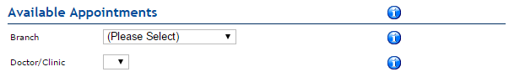

If your surgery has only one branch then there is no need to select the branch filter. However, there may be clinics which are not suitable for your requirements such as “Well Woman” or “Well Man” clinics which are gender specific. Also, there may be nurse appointments when you require a Doctor or vice versa.

As you select a Branch or a Doctor/Clinic, the available dates and times will be filtered accordingly.

Once you have the correct Branch and Doctor/Clinic selected you can make a selection from the available time slots.
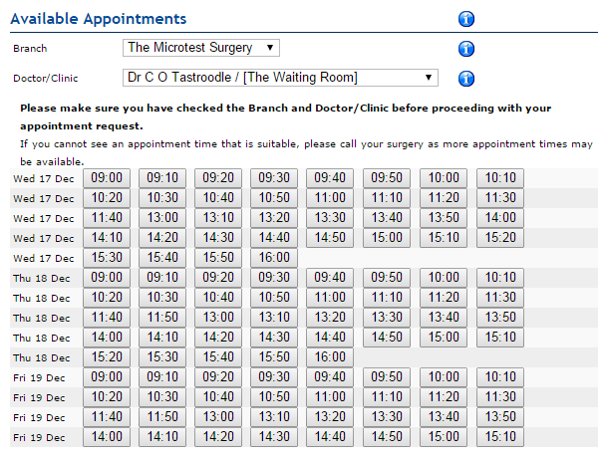

Select a suitable appointment by clicking on the time. This will take you to a confirmation screen.

Check that the details on the confirm appointment selection are correct and that you are booking a slot for the correct branch and doctor/clinic and that the date and time are suitable.

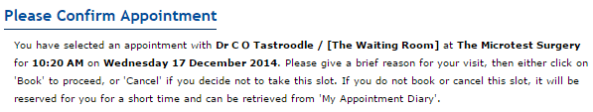

You can also add some text giving a brief “Reason for Visit” although this is not mandatory.

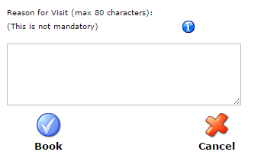

If at this stage you realise that this slot is not suitable you can cancel the booking by clicking on the Cancel button and you will be returned to the appointment booking system to select another slot.

Once you are happy with the booking and the text you can click on the “Book” button. This will trigger a confirmation email to be sent to yourself to confirm your request and will automatically book the appointment with the practice on your behalf.

If you visit the “My Appointment History” at this stage the slot will be shown as “Requested”. If you wish to cancel the appointment click “Change” and then click “Cancel” on the next page.

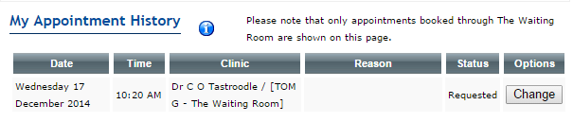

Once the slot is booked at the practice you will receive a second confirmation email stating that the appointment is confirmed.

If you visit the “My Appointment History” at this stage the slot will be shown as “Confirmed”. If you wish to cancel the appointment click “Change” and then click “Cancel” on the next page.

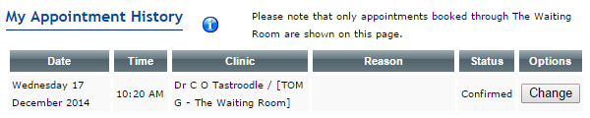

If you should accidently navigate away from the “Confirm Appointment” page or close the browser before clicking Book or Cancel the slot will remain reserved for you for fifteen minutes, allowing you to continue the process of booking using the “My Appointment History” menu item.

This page will list all your outstanding appointments, click on the “Change” button to the right of the appointment slot. This will take you to a page similar to the confirm/cancel page.

Medications

Your possible medications are listed within “Request Medication” section – these could be repeat prescriptions or acute drugs which have previously been prescribed. The possible availability status of each item is shown by the key below :-

Available to request
This drug can be ordered immediately. Simply tick the box for each of the items that you require.

Requested and pending issue
This drug has been requested and not yet processed by the practice. You may not request this item again at this time.

Recently Issued
Drugs that have recently been issued and processed by the practice will display this icon. Moving the mouse pointer over the icon will cause a message to appear stating when the item can be requested again. Your practice may contact you directly If these items are requested.

Although you can request items that are overdue a review or have recently been processed, the practice may decide to contact you regarding these requests.

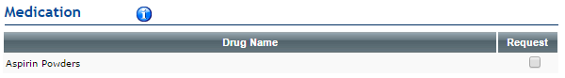

Click in the checkbox next to the items you wish to Request. Once the items are selected, click on the “Proceed with Request” button.

Medication ordering is a two stage process. You must request the required medication and then confirm the request on the Confirmation screen

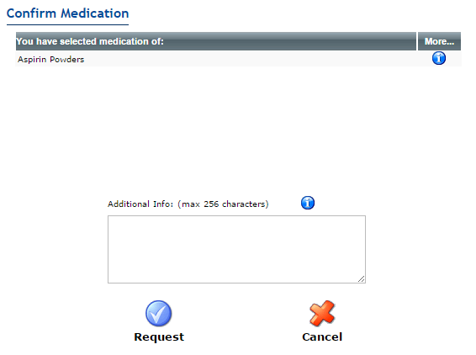

Add Additional information as required and click on “Request” to complete the request.

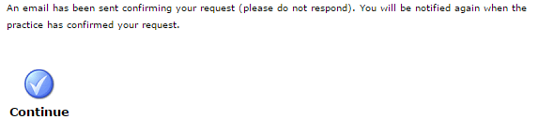

Verify that you have received an email confirming your request. This should arrive within a few minutes of clicking “Request”.

Once the practice has issued the prescription you will receive a second email, examples of which follow.

The Repeat ordering procedure has two emails associated with it:-
- Repeat Request

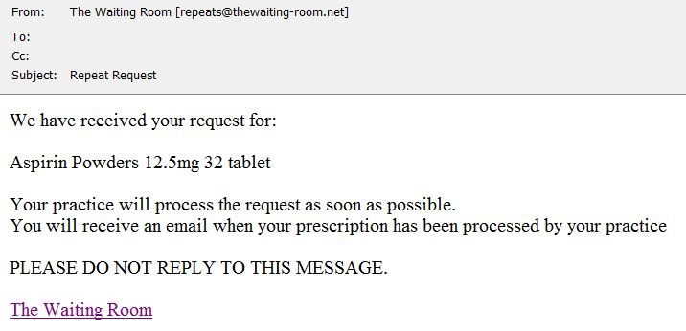

This email is sent by the Waiting Room system in response to a completed request. This is sent at the same time as an email to the practice containing the actual request.

If you do not have the above receipt, the request is most likely not complete and is in a pending state in the “My Repeat Prescriptions” section of the site.

- Repeat Confirmation

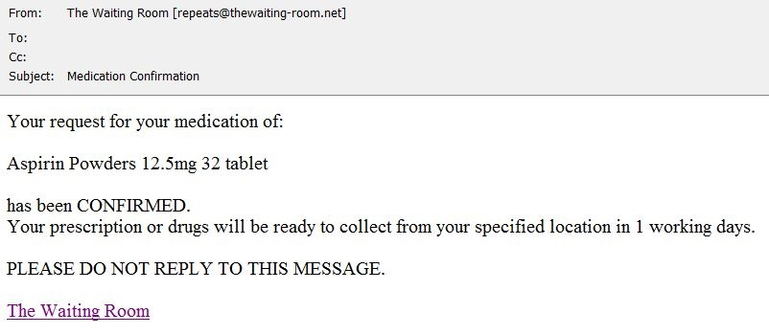

This email is sent only when the prescription requested has been issued by the practice.

My Medication History

This section of The Waiting Room holds the current requests for drug Items, the status of any request is held here.

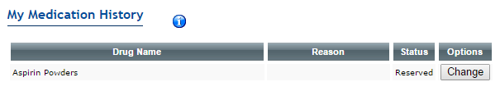

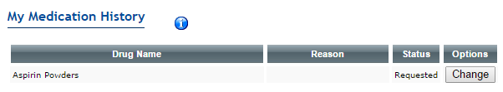

You should have an email receipt for each item in a “Requested” state. Items in a “Reserved” state have not been sent to the practice. Click on “Change” to complete a request or to cancel an outstanding item.

Allergies and Adverse Reactions

Allergies and Adverse Reactions are available from within the Waiting Room. If you see the following message when you click on the Allergies menu selection then please use the Contact Us link from the main menu to request the service from your practice.

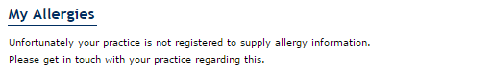

If your practice has enabled allergies then you will see the following when you click on the Allergies menu selection the first time.

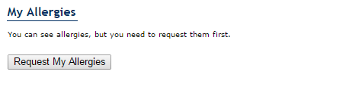

Click on the Request My Allergies button. This sends an automated request to your practice. You will be shown the following confirmation screen.

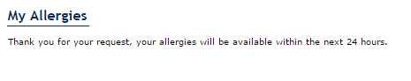

You will also receive the following confirmation email.

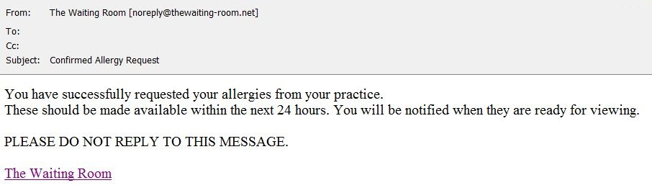

If you click on the Allergies menu selection before your request has been processed then you will see the following message. Please wait until at least 24 hours has expired or you have received a confirmation email. If you still see this message after 24 hours has expired and/or you have received the confirmation email then please use the Contact Us link in the main menu to report the issue to your practice.

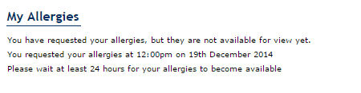

When your allergies request has been processed you will receive an email similar to the one below.

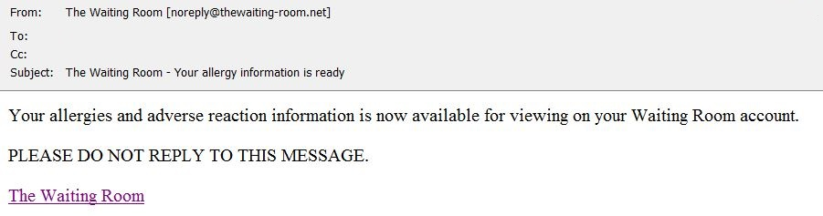

The next time you login to The Waiting Room and click on the View Allergies menu selection, you will see an output similar to the following if you have any recorded allergies or adverse reactions. You should contact your practice using the Contact Us option in the main menu or directly at the practice if you feel that the information shown is not correct.

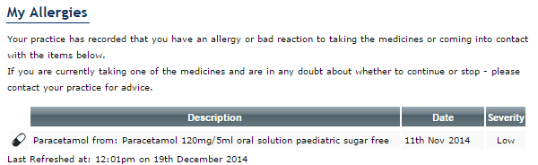

If you have no recorded allergies or adverse reactions then you will see an output similar to below when you click on the View Allergies menu selection. You should contact your practice using the Contact Us option in the main menu or directly at the practice if you feel that the information shown is not correct.

